Using Scouting For Motion Planning

John E. Lecky
University of Vermont
4/12/98

Initial Ideas and Results

The Scouting Formulation

Situation And Action Structure
// Situation
// theta,omega,t
#define theta s[0]
#define omega s[1]
#define t s[2]

// Action
// dTau,Tau,dt
#define dir a[0]
#define dTau a[1]
#define Tau a[2]
#define dt a[3]

Pick Action
void PendulumSimulator::PickAction(double* a)
{
int curDir=dir;
int d;
if(curDir==-2)
{
d=rand()%2;
}
else if(curDir==2)
{
d=rand()%2-1;
}
else
d=rand()%3-1;

curDir+=d;
dir=curDir;

dTau=(double)(curDir)/2.*tauSlew;

// anticipate and prevent overshooting Tau limits
double tauDist=dTau*(double)integrationsPerStep;
if(Tau+tauDist>maxTau)
dTau=(maxTau-Tau)/integrationsPerStep;
else
if(Tau+tauDist<minTau)
dTau=(minTau-Tau)/integrationsPerStep;
}

Next Situation

void PendulumSimulator::NextSituation(double* s,double* a)
{
for(int i=0; i<integrationsPerStep; i++)
{
// straight Euler technique; walk the system model
Tau += dTau; // keep Tau ramping

double thetadot = omega;
double omegadot = MLLinv * (Tau - B*omega –
MGL*sin(theta));

theta = theta + thetadot*dt;
omega = omega + omegadot*dt;

t+=dt;
}
}

Goal Check
BOOL PendulumSimulator::GoalCheck(double* s)
{
// EXAMPLE: Force solution at a specific time
//if(t<4.5 || t>5.0) return FALSE;

// STANDARD: Are we in position/velocity spec
if(fabs(theta-finalTheta)<finalThetaTol &&
fabs(omega-finalOmega)<finalOmegaTol)
return TRUE;
else
return FALSE;

// EXAMPLE: Force steady state solution: check to see
// if we have been in the final state for at least K timeslots
//if(fabs(theta-finalTheta)<finalThetaTol &&
// fabs(omega-finalOmega)<finalOmegaTol)
//{
// nConforming++;
// if(nConforming>K) return TRUE;
// else return FALSE;
//}
//else
//{
// nConforming=0;
// return FALSE;
//}
}

Plenty of Torque
An easy solution to find.

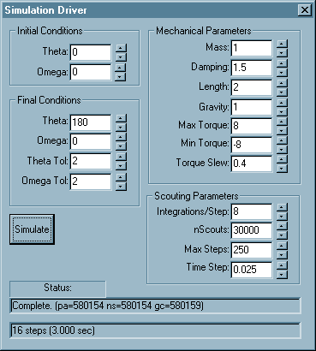
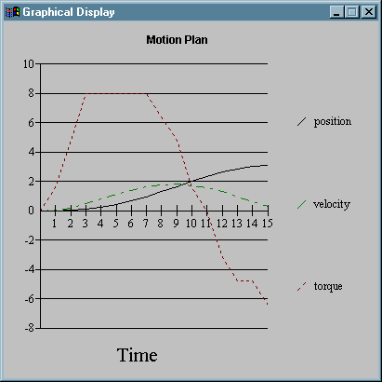

Torque Severely Constrained
A difficult solution, not immediately obvious.

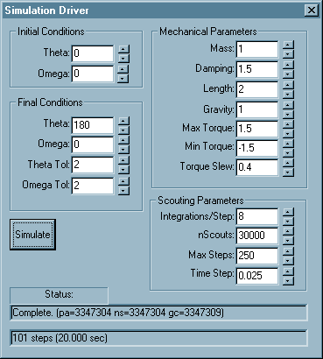
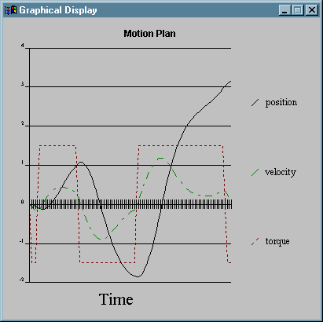

Assymetric Torque
An unusual problem with a simple solution.

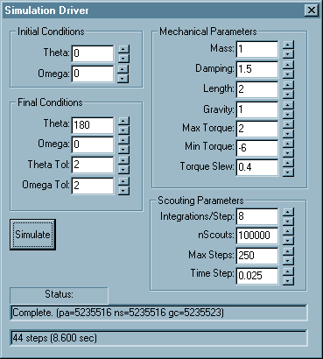
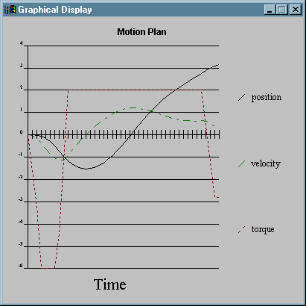

Non-linear Damping
This example uses 